Operational Amplifiers III
We have looked at the limitations that the slew-rate limit of an op-amp places on the performance of an amplifier. Now we have to look at the effect that the output current limit has and to see how to build an audio amplifier. Our final circuit differs from a commercial audio amplifier only in lacking circuitry to protect the output transistors from damage by improper loading or by running the thing at full blast for hours on end.

Task 1: A very poor speaker amplifier
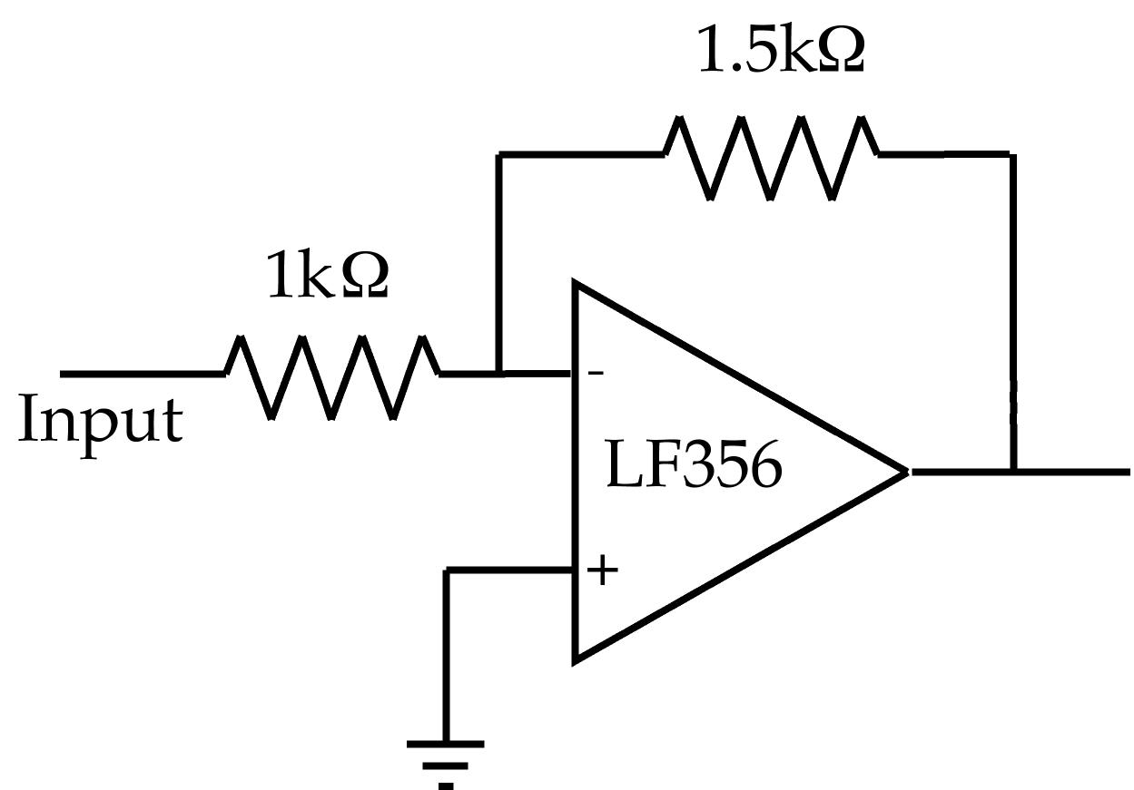
Start by building the gain of 1.5 inverting amplifier shown in the figure on the left. Connect the input to a 0.1 Vp-p, 1 kHz, sinewave from your signal generator.

a) Paste an image of the input and output below.
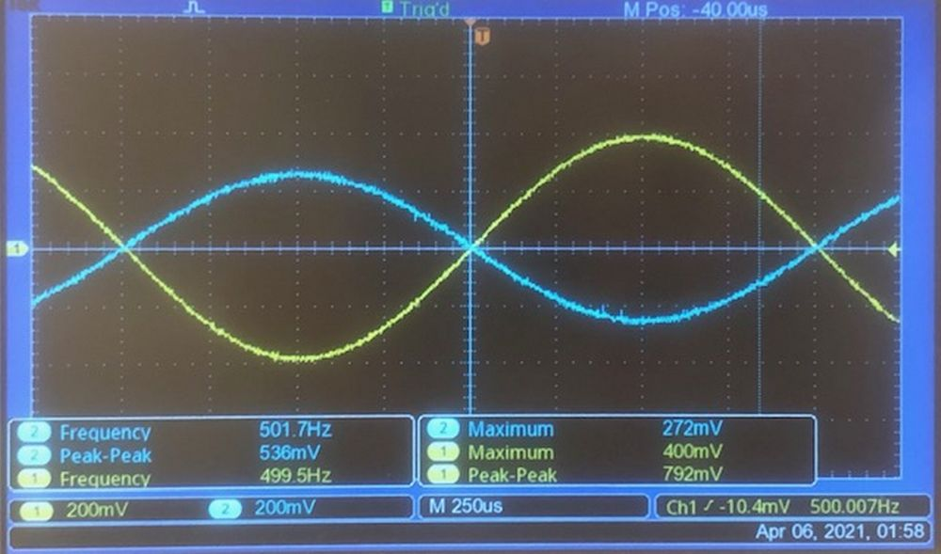
b) Is the output a good sinewave?
Yes.
c) Now connect the output to your loudspeaker. Paste an image the output below and describe, as carefully as you can, what you see and hear. In particular is the output a faithful copy of the input or is it distorted?
The output is a faithful copy of the input; it is not distorted.
d) Now increase the input to a 1 Vp-p sinewave. Again, paste an image below and describe what you see and hear.
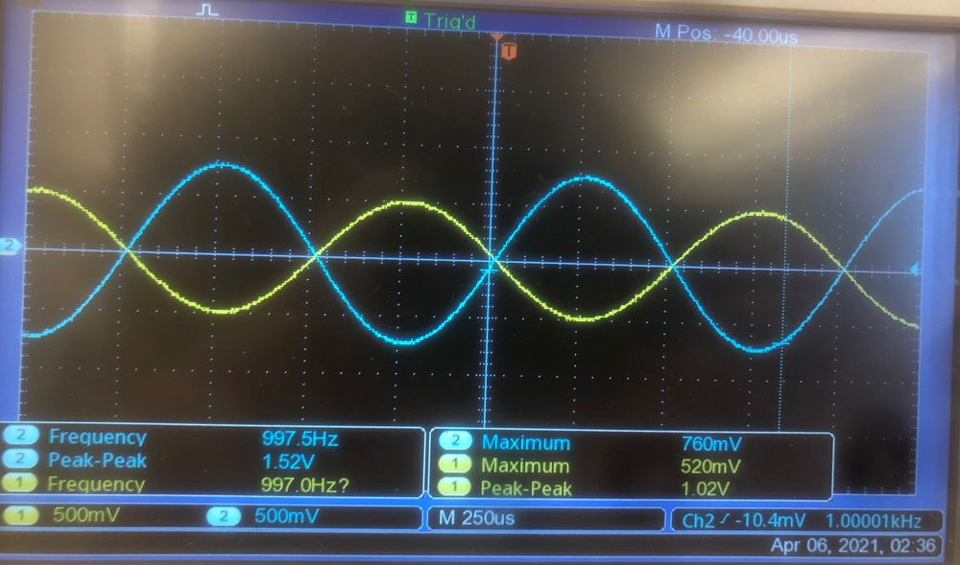
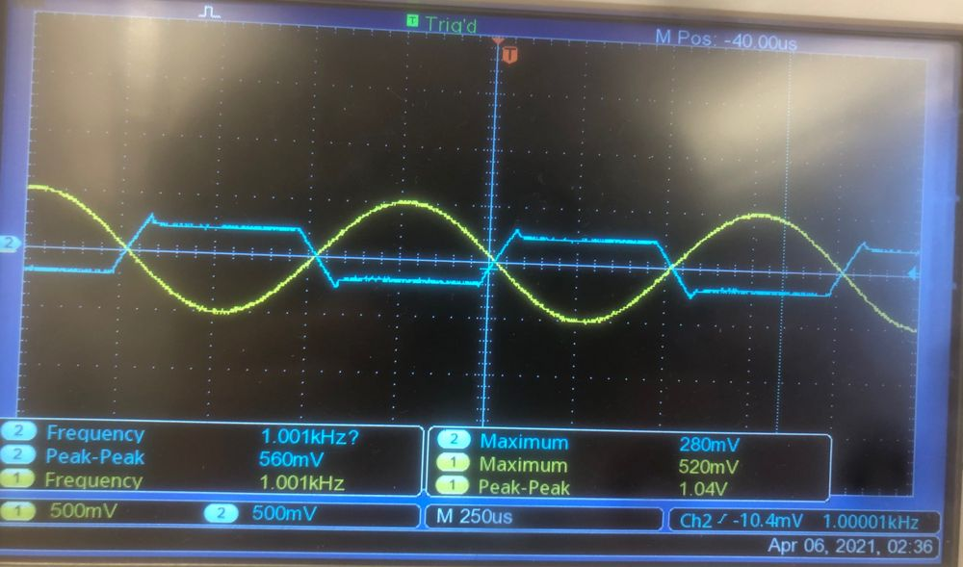
e) If the output is not a perfect sine wave then where is it distorted?
Without the speaker connected, the output is a good sine wave. With the speaker connected, the peaks of the output wave are clipped.
f) Explain what causes this distortion.
At higher voltages, the speaker needs more current than the amplifier can provide.
g) Based on your measurements what is the maximum current that your op-amp can deliver in both the +ve and –ve directions (justify your answer!). How do these compare to the data-sheet values of ±25mA?
The voltage maxes out at 210mV and -210mV. We’re using an 8 Ohm speaker, so the max current that the op-amp can deliver is ±.21/8 = ±26.3mA. This matches the data-sheet values of ±25mA.
h) Replace the sine wave input with the audio output from your computer and play a short segment of a sound file. How does the sound compare to playing the same file through the computer directly?
At low volumes, the sound is not distorted. At high volumes, the waveform gets clipped, so the music sounds “maxed out,” sort of like when a sound is too loud for a microphone.

Task2: A rather better amp.
Now build the simple power-booster stage in the figure below, keeping wires as short as practical!
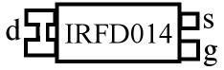
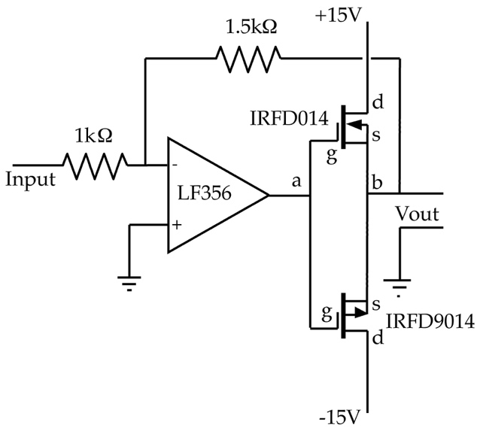

Note that we are using slightly different FETs than you are used to. They are very similar to our old 2N7000 and ZVP4105 but are in a package that can handle rather more power. The IRFD9014 has exactly the same pinout as the IRFD014.
BEWARE: The labels on the FETs are not easy to read and the numbers awfully similar. Make sure you have the right FET in the right place.
a) Without the speaker connected, display the voltages at point a and point b.
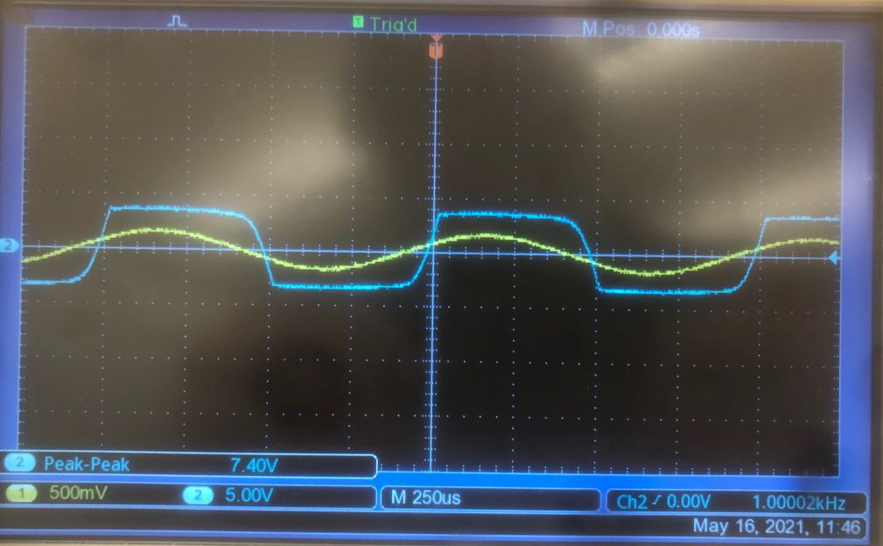
b) Explain how the circuit works and why the two voltages that you measured make sense.
The op-amp golden rules indicate that the op-amp will optimize twoard equalizing its inputs. Since one of its inputs is grounded, it’s going to manipulate the FETs to make Vout a sinewave that’s out of phase with the input wave, so that the voltage at the inverting input of the op-amp is also 0. To do this, it needs to produce the blue wave shown above.
c) Now connect the loudspeaker and again paste an image of the voltages at points a and b. Describe as carefully as possible any difference between the picture in part 2 and the picture now. (NOTE please don’t leave the speaker connected for too long. The FETs can overheat since they do not have heatsinks, also we might all go deaf!)
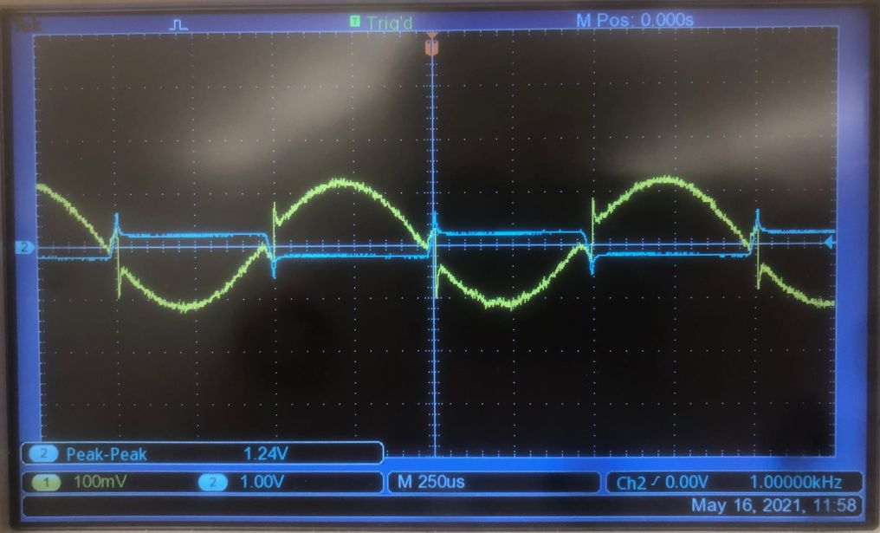
d) What is the maximum current being delivered to the loudspeaker now?
Both op-amp inputs are at 0V, so V=IR → 4.8 = I*1500 → I = 3.2mA.
e) Repeat the measurement at 10kHz. Remove the speaker or we will all hate you!
Paste the image below and describe and explain the differences.
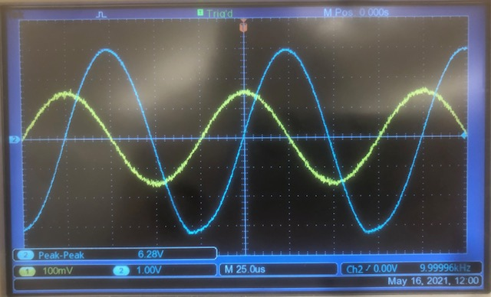
Now there’s no clipping. Having a hard time understanding this.
f) Repeat the test with the computer sound file and discuss any difference between the sound from this circuit, that from the first circuit, and that from the computer.
The sound from the computer is not clipped, but is pretty quiet. This amplifier has less distortion than the first one, but also less volume.

Task 3: A decent amp.
Now alter the power booster by adding a Zener diode and associated resistors as shown in the adjacent. You may have to select from among the several Zener diodes in my collection to find the one that gives the least distortion.
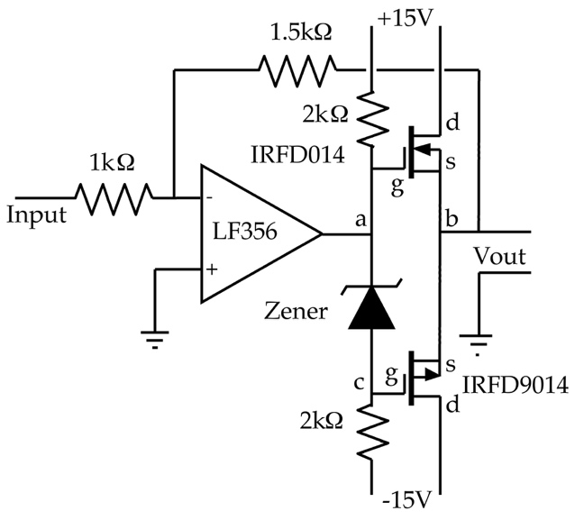

a) Return to the 1 kHz, 1Vp-p sinewave input. Paste images showing the voltages at points a, b, and c.

b) Compare the output shape and sound to those in the previous sections.

c) Explain in detail the shapes and levels of the signals in the three different locations and explain how the Zener diode both accounts for the new shapes and gives so much better a sinewave.

d) Once more drive the circuit with the sound from your computer and compare the sound you hear to the sounds from the computer and from the previous circuits.

e) Which of the circuits that you have built is the best sound amplifier? In what way?

